High Precision Impedance Meter

**Introduction:**

An impedance meter is a device that allows for the measurements of impedance or resistance to the flow of an alternating current. An impedance meter designed for low magnitudes, allows for the measurements of impedance in chemical reactions or when working with enzymes and molecules [1].

The methodology used for the implementation of the low impedance meter consists of a power stage, a signal generation stage as well as a sensing and communication stage. The power stage implemented allows for the use of AC current as the power for both an arduino microcontroller as well as an HC-05 BT module to send the impedance sensed to a mobile device, or to the Arduino IDE monitor, using 2x Hi-Link ultra-compact power modules. These power modules allow for a constant output of 5V DC at 0.6A. The impedance meter for low magnitudes also features an LM317T voltage regulator as part of the signal generation stage, to adjust and amplify the voltage response from the impedance being measured. This implementation allows for the accurate measurements of impedances in the range of ones and tens of Ohms, although further tuning may be required. Another approach for the power stage is also proposed using an AC to DC capacitive transformerless configuration in case that the Hi-Link power modules are to not be used.

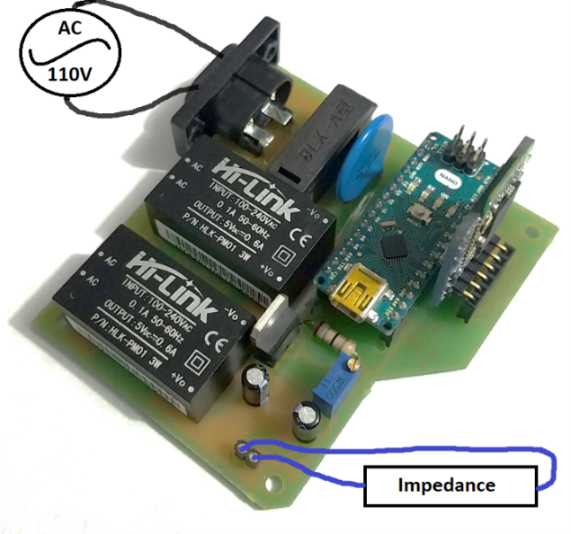**Materials:**

1. 2x Hi-Link 5V 0.6A 3W
2. BLX-A Fuse Holder
3. Varistor S20K11
4. LM317T
5. Arduino Nano
6. HC-05 BT
7. 2x Cap. 1uF
8. AC connector
9. Pin Connector
10. Res. 18 Ohm
11. Trimmer 50 Ohm

Illustration 1: Connection Diagram

**Component Explanation:**

**Hi-Link HLK-PM01:**

The 3W (5V DC, 600mA) ultra-small series module power supply is a small-volume, high-efficiency AC DC power module, which has the advantages of global input voltage range, low temperature rise, low power consumption, high efficiency, and high reliability [2]. The HLK-PM01 can operate with input voltages in the range 90-245VAC with an efficiency of 72%. If higher efficiency is needed out of the power module, the Hi-Link power module with reference HLK-20M05 features a 5V DC output and 20W. The operation voltage is the same as that of the HLK-PM01, however, it has an 80% efficiency. Furthermore, for this implementation, the HLK-PM01 3W power module is more than enough to power the signal generation stage as well as the sensing and communication stage.

**LM317T:**

The LM317 is an adjustable linear voltage regulator capable of supplying at its output under normal conditions a range from 1.2 to 37 Volts and a current of 1.5 A. In its smallest configuration, a pair of resistors is enough to obtain the required voltage [3]. A basic adjustable regulator using the LM317T uses the following formula to adjust the output voltage, as can be observed in the following illustration:

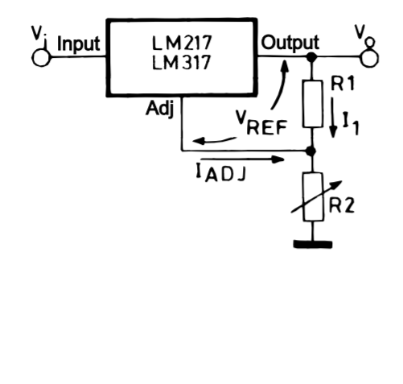

Illustration 2: LM317T Voltage Regulator

**Power Stage:**

Since the device is to power a microcontroller and a BT module through AC-DC converters, it is necessary to implement both a fuse as well as a varistor to protect the device from power surges. The circuit has a BLX-A fuse holder for crystal fuses with a maximum amperage rating of 9 amps. However, a fuse of about 2-3 amps should suffice for this implementation.

The varistor used is the S20K11, which has a maximum power rating of 10W. When a high voltage surge is applied, which surpasses the varistor voltage, the varistor suppresses the voltage to protect the circuit. It protects the circuit by lowering the resistance value as the voltage input rating increase; as such, for higher voltages, the resistance of the varistor lowers and resembles a short circuit. The S20K11 varistor used for this implementation has a maximum voltage rating of 11VAC as well as 14VDC. However, while the voltage input rating is under the specified threshold, the varistor works as a capacitor, or rather a filter to diminish high frequencies [4]. This behavior also helps protect the circuit from electronic noise generated by other components.

Now that the circuit is protected, two Hi-Link HLK-PM01 ultra-compact power modules are used to power each of the stages: the signal generation stage as well as the sensing and communication stage. A diagram of the power stage is shown in the following image. In case that the Hi-Link modules are to not be used, an implementation using a capacitive transformerless power supply is also shown in a later section.

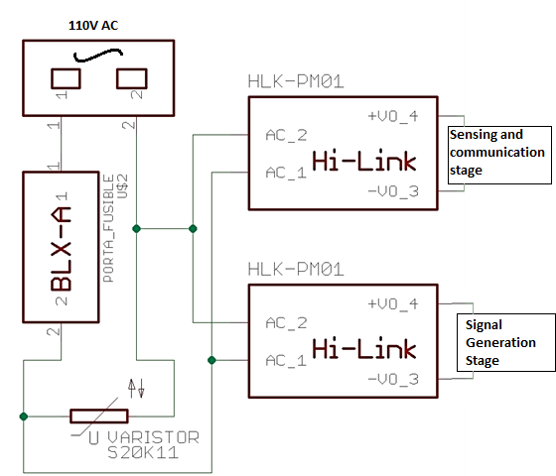

Illustration 3: Power Stage Diagram

**Signal Generation Stage:**

The signal generation stage allows for the sensing of low impedances by converting the impedance in the sensing module to a voltage which can be then measured using the Arduino Nano microcontroller. This process is done by modifying the parameters of equation (1) once the impedance is connected to the impedance sensing module. As such, the output value Vo of the LM317T is modified, which then allows for a voltage response to an impedance input. The LM317T generates a constant current I, since the 18 Ohm resistor’s value does not change. Using V = I*R, the microcontroller is able to properly measure the device using the ADC.

To properly adjust the voltage caused by the impedance sensing module, an LM317T voltage regulator is used. The voltage of the signal generated by the impedance can be observed in the following equation as well as in the following graph. The equation is obtained by taking into account values for the trimmer operation percentage from 0 to 50%. It should be noted that the following equation was created by taking into account impedance input values of 1 Ohm and 2 Ohm as the implementation was designed for values in this range. It should be noted that the implementation can take into account values of up to tens of Ohms, although further calibration may be needed. The following image shows the data obtained using the signal generation stage to create the exponential regression (2). The trimmer operation was kept below 50% since it also affects the voltage output of the LM317T in an exponential manner. As such lower trimmer operation values would provide a more linear regression equation, which in turn would make the signal generation regression easier to calculate.



Illustration 4: Signal Generated Graph

The following image shows the signal generated by using a 1.5 Ohm impedance at 20% trimmer operation. When the simulation is compared with equation (2), the is an absolute error of 0.000814 or 0.5%. It should be noted that values below the 1 Ohm and above the 2 Ohm threshold would have larger error values.

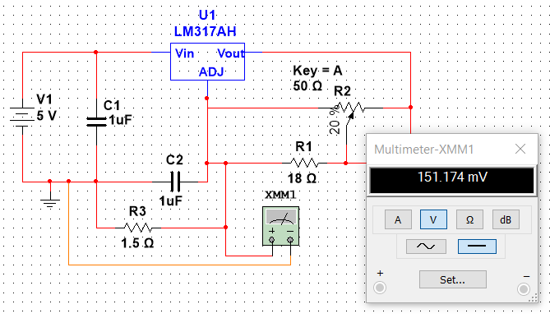

Illustration 5: Signal Generation Example

The diagram of the signal generation stage is shown below.

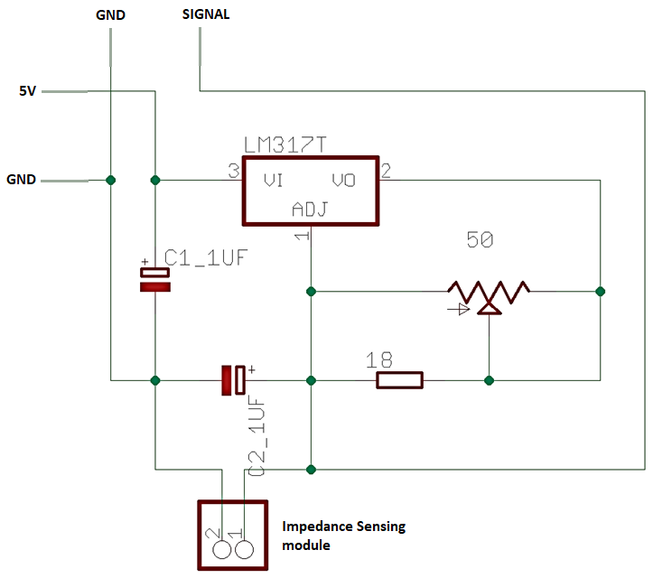

Illustration 6: Signal Generation Diagram

**Sensing and Communication Stage:**

The sensing and communication stage consists of an Arduino Nano microcontroller as well as the HC-05 BT module. The BT module’s serial communication is connected to the Arduino’s serial port, thus, the communication between the two devices is as if they interacted through the Arduino IDE monitor. It was created this way as to allow the user to interact with the microcontroller even if the HC-05 BT module is not available or if the implementation done by the user does not require a BT module. The Arduino IDE is an open-source Java-based application that allows for a fast and easy way to upload code to the ATmega328 microcontroller chip [6].

The Arduino Nano is a small board based on the ATmega328. It features a 6-20V unregulated power supply in pin 30 and a 5V regulated power supply in pin 27. The Hi-Link module is connected to pin 27 [5]. The HC-05 BT is an easy-to-use Bluetooth SPP (Serial Port Protocol) module, designed for transparent wireless serial connection setup. Its communication is via serial communication which makes an easy way to interface with controller or PC. HC-05 Bluetooth module provides switching mode between master and slave mode which means it able to use neither receiving nor transmitting data [7].

A diagram of the sensing and communication stage is shown below.

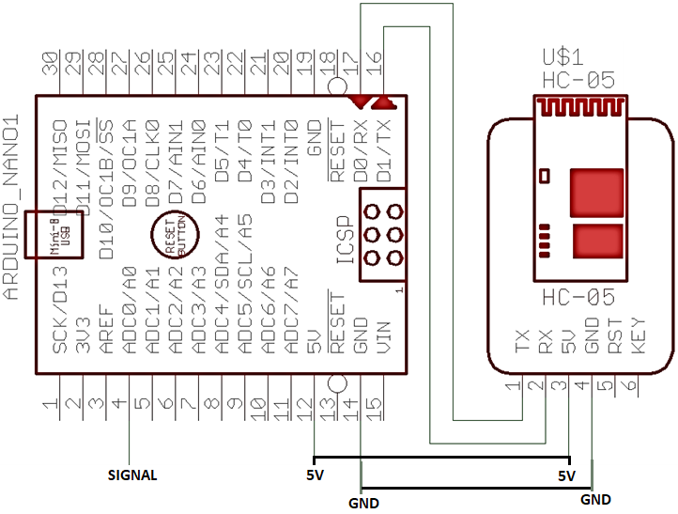

Illustration 7: Sensing and Communication Diagram

**Capacitive Transformerless Power Stage:**

A different approach replacing the power stage previously shown with a capacitive transformerless power supply is proposed. The following configuration is obtained from [8]. An example diagram of the schematic of the power supply is shown in the following illustration. This power stage is proposed due to its cost. Although an AC-DC converter can often be created using a transformer and a rectifier circuit, if the device implemented only consists of a microcontroller and a few passive components, the cost of the AC-DC converter is not effective. This implementation also takes a lot of space when compared with the capacitive transformers power stage.

|  |  |
| --- | --- |
| Variable | Value |
| Vrms (VAC) | 110 |
| Vz (VDC) | 5.1 |
| F (Hz) | 59.5 |
| C1 (uF) | 6.8 |
| Imin (mA) | 150 |
| Capacitor Tolerance (%) | 20 |

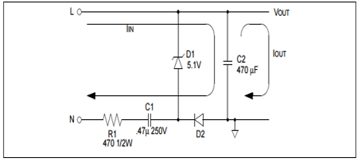

Illustration 8: Example Schematic Table 1: Assumed Values

Using the formulas found in [8], one can modify the values of the components to suit the needs necessary. The values of Vrms, Vz, f, C1 and Iman are assumed as to find the value of R1.

Getting a value of 9.84 Ohm, from (3), the value is set at 10 Ohm. After which, assuming both the lowest and largest values of the components, the Imin and Imax can be correctly calculated to make sure that the power ratings of the components will be properly taken into account. The values obtained are as follows.

|  |  |  |
| --- | --- | --- |
| Variable | Min Value | Max Value |
| Vrms (VAC) | 110 | 120 |
| Vz (VDC) | 5.1 | 5 |
| F (Hz) | 59.5 | 60.1 |
| C1 (uF) | 6.8 | 6.8 |
| R1 | 10 | 10 |
| Capacitor Tolerance (%) | 20 | 20 |
| Resistor Tolerance (%) | 5 | 5 |

Table : Min and Max Assumed Values

After the minimum and maximum current is found, the values of the power ratings of the components are taken into account. This must be done to make sure that the power stage won’t cause problems for the microcontroller and the BT module in the form of busted components that may cause variations in the current and as such damage the circuits. The following equations are used to find the power ratings of the components.

These values are then multiplied by 2, to account for possible power surges (It should be noted that although the circuit does possess both a fuse as well as a varistor, some components may be damaged in the case of a power surge). After which, the values obtained create the following schematic. It should be noted that the higher the capacitance of C2, the less ripple the power source will show, as such a value of 8.2mF was specified. This value may as well be larger if the resulting ripple of the power stage is still too much for the user. A rectifier bridge can also be added to further reduce the ripples at the output of the circuit.

[Capacitive Transformerless Power Stage](https://youtu.be/r2ekn8KQhSQ) [https://youtu.be/r2ekn8KQhSQ] shows a video of the operation of the circuit, taking into account both considerations. A simulation of the operation of the module can be observed in Annex 2.



Illustration 9: Capacitive Transformerless Power Stage

**Diagram:**

The overall diagram of the implementation of the three stages can be observed below. The implementation is done using the power stage with the Hi-Link ultra-compact power modules. It should be noted that this implementation is done using the Hi-Link modules instead of the capacitive transformerless power supply.

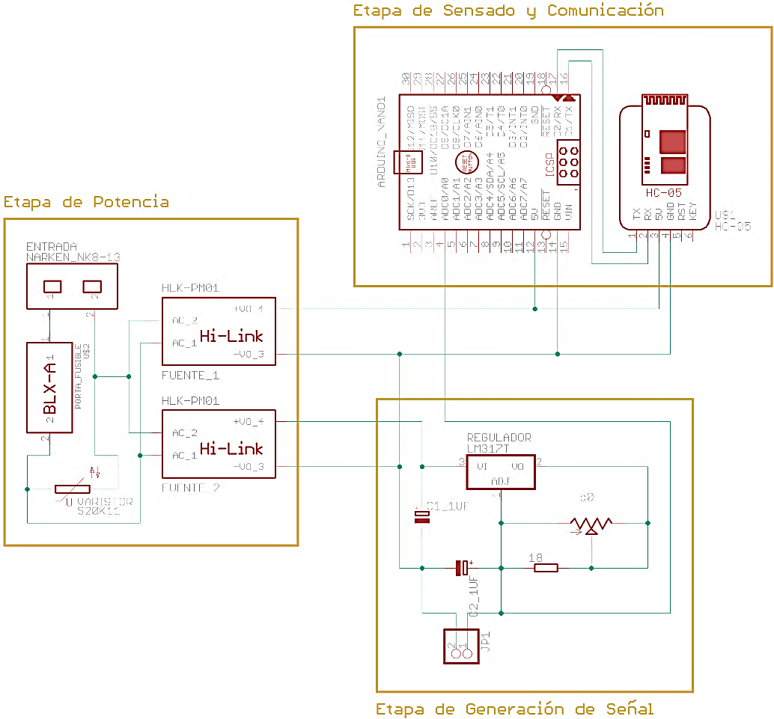

Sensing and Communication Stage

Power Stage

Signal Generation Stage

Illustration 10: All Stages Diagram

**Code:**

The code for the implementation can be observed below. It should be noted that the communication implemented with the device is strictly through BlueTooth; thus, if the implementation is to be done using the Arduino IDE monitor, the code should be modified to print the results without taking into account the BT module. It should be noted that this implementation makes use of the EEPROM library which allows the arduino to use non-volatile memory. The code can be observed in Annex 1. The implementation already uses the Serial communication pins of the Arduino to communicate with the BT module, as such the code modifications needed to be implemented are not extensive. It should also be noted that if a second serial connection is to be implemented through a USB to TTL serial, both the BT module as well as the Arduino IDE monitor could be used simultaneously. It should also be noted that the PCB diagram shown does not take this into account, thus if it were to be implemented, a new PCB diagram should be taken into account.

**Implementation:**

For the implementation, a PCB is designed to allow for a more organized circuit. A higher resolution image of the PCB layers can be observed in Annex 3 and Annex 4. It should be noted that to make the implementation easier to use, the fuse holder should be placed in a spot with easy access, as to allow for the replacement of the fuse in case of a power surge.

7.4cm

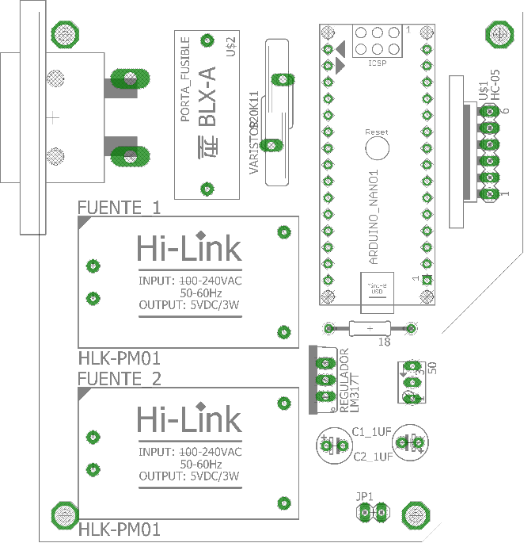 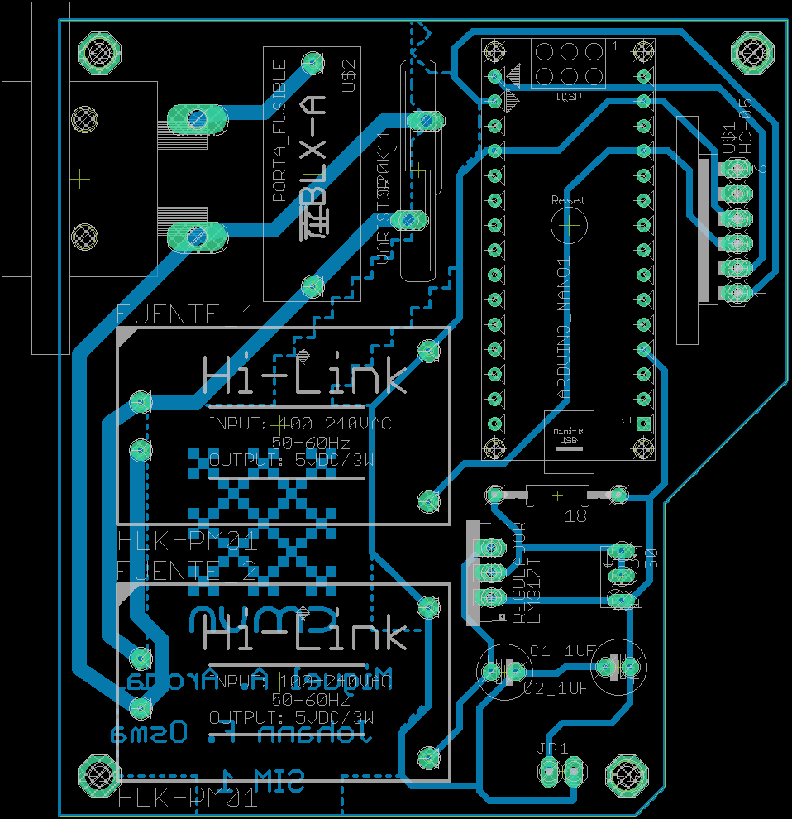

8.1cm

Illustration 11: PCB COMP layer Illustration 12: PCB design

The final implementation using the PCB diagram above can be observed below.

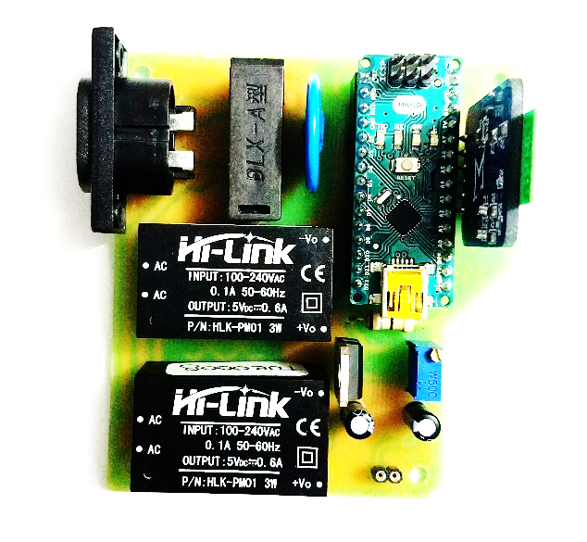 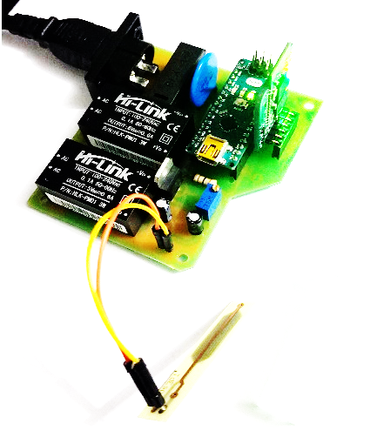

Illustration 13: Final Implementation Top View Illustration 14: Final Implementation with electrode

For this implementation, an electrode was also employed to observe the impedance change when working with enzymes or molecules. The electrode implementation can be observed in illustration 14. In the following illustration, a picture of the electrode implemented is shown.

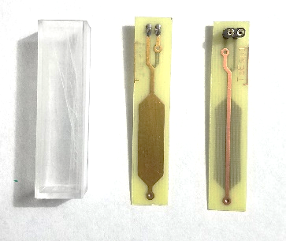

Illustration 15: Electrodes

**Results:**

The validation of the circuit is done placing resistors in the impedance sensing module. It should be noted, that to obtain the most accurate results, the resistors themselves should be as precise as possible. As such, it is recommended to use 1% tolerance resistors for this validation. The validation is done using resistors in the 1 Ohm and 2 Ohm range. The following data was obtained.

|  |  |  |
| --- | --- | --- |
| Resistor Value | Measured Value | Percentage Error |
| 1.5 Ohm | 1.52 Ohm | 1.33% |
| 1.62 Ohm | 1.64 Ohm | 1.23% |

Figure : Results

The data collection process can be observed in [Device Validation Process](https://youtu.be/2dv06NhYr4M) [https://youtu.be/2dv06NhYr4M].

**Observations:**

It should be noted that equation (2) is taken using impedances of 1 Ohm and 2 Ohm. Thus, the larger the impedance in the sensing module, the larger the error when compared with the theoretical values. The calibration process can be performed by measuring the voltage values caused by the impedance in the sensing module; it should be noted that the calibration is to be done near the values that the low impedance meter is to be used for. For this implementation, values of about 2 Ohms were sufficient. It should also be noted that the trimmer operation was kept below 50% as to allow for a more linear regression. The errors obtained in the results were always 0.02 Ohm off from the original value, which is a constant value in a lineal system. Thus, corrections in the software implemented would suffice to compensate for this uncertainty.

It should also be noted that if the power stage is to be replicated using the capacitive transformerless method, the capacitor used should be made from polyester. An example of the capacitive transformerless power stage using electrolytic capacitors can be observed in [Capacitive Power Stage](https://youtu.be/EOQJMa6S264) [https://youtu.be/EOQJMa6S264].

**References:**

1. *How to* Use an Impedance Meter. Open new window. (n.d.). <https://www.hioki.com/global/learning/how-to/u-impedance-meters.html>.
2. Ultra-compact power module HLK-PM01. (n.d.). http://www.hlktech.net/product_detail.php?ProId=54.
3. *Regulador de voltaje ajustable L317 / LM317 / LM317T variable de 1.2V a 37V 1.5A*. Tecnopura. (2020, October 14). https://www.tecnopura.com/producto/regulador-de-voltaje-ajustable-l317-lm317-lm317t-variable-de-1-2v-a-37v-1-5a/.
4. *Varistor and the Metal Oxide Varistor Tutorial*. Basic Electronics Tutorials. (2018, July 9). https://www.electronics-tutorials.ws/resistor/varistor.html.
5. *Arduino Nano V3 - ATmega328 5V + Cable USB Compatible*. Electronilab. (2021, July 17). https://electronilab.co/tienda/arduino-nano-v3-atmega328-5v-cable-usb/.
6. Team, T. A. (n.d.). *Software*. Arduino. https://www.arduino.cc/en/software.
7. *HC-05 Bluetooth Module*. (n.d.). https://www.gme.cz/data/attachments/dsh.772-148.1.pdf.
8. Reston Condit Microchip Technology Inc. (2004). *Transformerless Power Supplies: Resistive and Capacitive*. Transformerless Power Supplies. http://ww1.microchip.com/downloads/en/AppNotes/00954A.pdf.

**Annexes:**

Code:

#include <EEPROM.h>

// Variable Declaration - - - - - - - - - - - - - - - - - - - - - - - - - - - - - - - - - - - - - - - -

float ohm1;

int addr = 0;

int ledState = 13; /* Pin 13 declared as Led State. */

String orden = ""; /* Variable that holds the dataobtained through UART BLUETOOTH. */

char unCaracter; /* Variable that holds one char. */

int actADC = 0;

int lectura = 0;

// Configuration - - - - - - - - - - - - - - - - - - - - - - - - - - - - - - - - - - - - - - - - - - - -

void setup() {

Serial.begin(9600);

pinMode(ledState,OUTPUT);

analogReference(INTERNAL); //Ref = 1.1V

// Led State

digitalWrite(ledState,HIGH);

delay(500);

digitalWrite(ledState,LOW);

delay(500);

digitalWrite(ledState,HIGH);

delay(500);

digitalWrite(ledState,LOW);

}

// Principal Program- - - - - - - - - - - - - - - - - - - - - - - - - - - - - - - - - - - - - - - - - - -

void loop(){

/* A string is amde form the char obtained through the UART Bluetooth*/

if (Serial.available()){

while (Serial.available()){

delay(3);

unCaracter = Serial.read();

orden += unCaracter;

}

}

/* If the state received is ON, the ADC is turned on. */

if (orden == "ON"){

digitalWrite(ledState,HIGH);

ohm1=0;

actADC = 1;

orden = ""; /* Clean the activation variable as to not repeat the cycle. */

}

/* If the state received is OFF, the ADC is turned off. */

if (orden == "OFF"){

digitalWrite(ledState,LOW);

actADC = 0;

orden = ""; /* Clean the activation variable as to not repeat the cycle. */

}

/* If the state received is READ, the ADC is turned off. */

if (orden == "READ"){

lectura = 1;

orden = ""; /* Clean the activation variable as to not repeat the cycle. */

}

// Analog measurements

if (actADC == 1){

addr = 0;

for (int i=0; i<60; i++){

ohm1=analogRead(0)/4;

EEPROM.write(addr, ohm1);

addr = addr + 1;

delay(990);

ohm1 = ohm1*4;

ohm1 = ohm1 * 10.96;

ohm1 = ohm1 / 1023;

Serial.println(ohm1);

}

actADC = 0;

Serial.print('F');

Serial.print('I');

Serial.println('N');

}

// EEPROM reading

if (lectura == 1){

addr = 0;

for (int i=0; i<60; i++){

ohm1 = EEPROM.read(addr);

ohm1 = ohm1*4;

ohm1 = ohm1 * 10.96;

ohm1 = ohm1 / 1023;

Serial.print(addr);

Serial.print("\t");

Serial.println(ohm1);

addr = addr + 1;

delay(500);

}

lectura = 0;

}

}

// - - - - - - - - - - - - - - - - - - - - - - - - - - - - - - - - - - - - - - - - - - - - - - - - - - - -

Capacitive Transformerless Power Stage Simulation

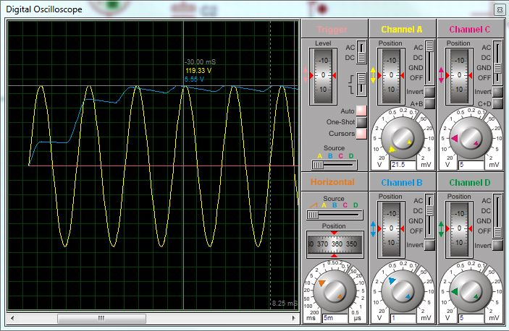

PCB COMP layer



PCB Diagram

